**Flow of User Interface**

Login/Signup Page - > Landing Page - > Dashboard

**General theme:**

**Design a sleek, futuristic website for a state-of-the-art voice AI platform called** *NeuraVoice*. The theme should be clean, minimal, and tech-forward — similar in feel to vapi.ai. Use a dark or gradient-rich background with soft glow effects and micro-interactions. Highlight NeuraVoice's core offerings: no-code voice bot creation, real-time conversations, and multi-voice personalization. The landing page should focus on action with two clear CTA buttons — one to 'Create a Bot' and another to 'Test a Voice'. Use modern typography, subtle animations, and a floating AI agent visual or waveform animation to reinforce the brand's intelligent, interactive feel. Avoid heavy text; prioritize intuitive UX, visual clarity, and a feeling of cutting-edge innovation.

**Website Functionalities:**

**First: Login/Signup Page**

Option to sign up via a Google account for first-time users or log in if logged out via a Google account.

**Second: Landing Page**

Headers:

1. Left: NeuraVoice Logo
2. Centre: Solution, About (On click - > these two buttons will just scroll on the landing page respective sections)
3. Right: Design Studio (This button will take me to the dashboard)

Section 1:

One line about NeuraVoice (Add - AI & state of the art), and just below it, two buttons:

Button 1 : Assemble (This button will take me to the dashboard)

Button 2 : Talk to LenDen (This button will have Livekit API to test)

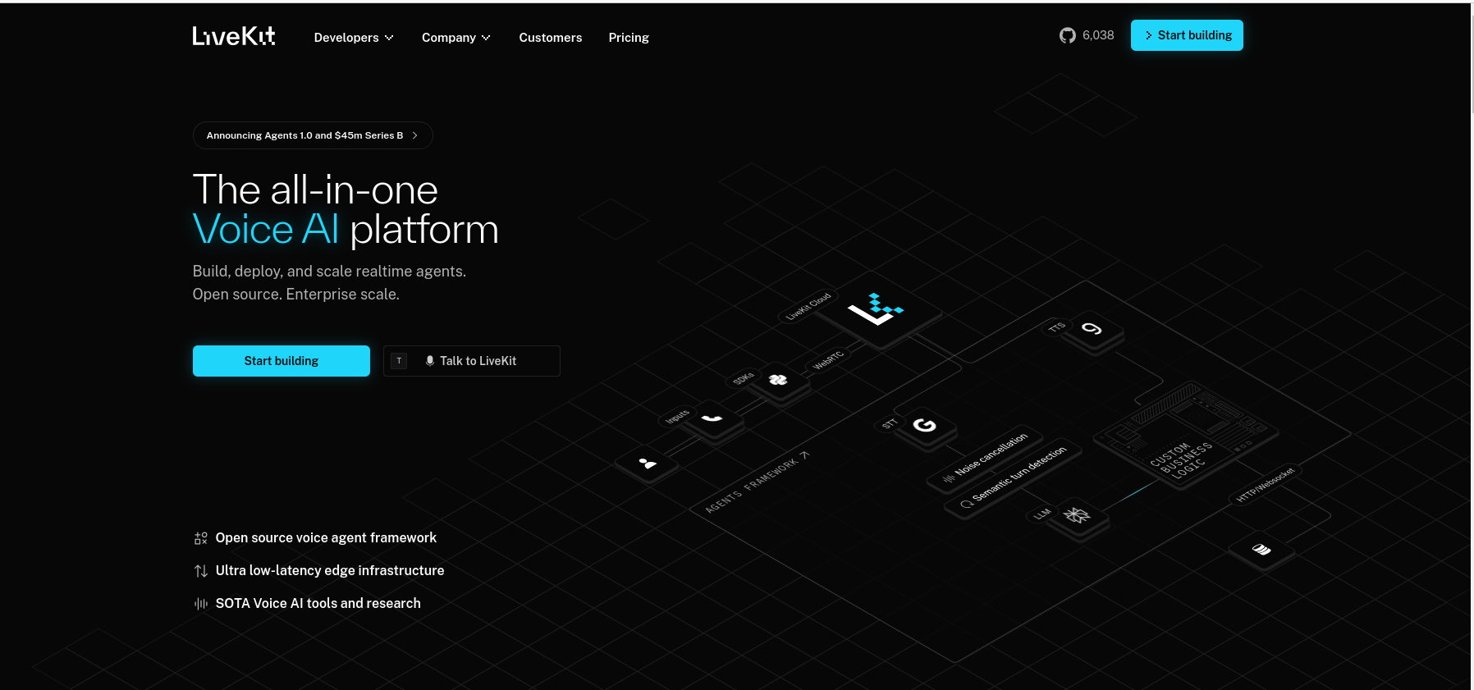

Section 2:

How does it work section? Create a visually engaging "How Does It Work?" section for the NeuraVoice landing page.

Use a modern, step-by-step horizontal or vertical layout with icons and short descriptions for each step.

Steps to include:

1. Upload Knowledge Base: Users upload their business documents, FAQs, or data to train the AI.

2. Choose Voice: Users select from a variety of lifelike AI voices to represent their brand.

3. Assign a goal

4. Test the bot.

5. Integrate with systems and go live in 5 minutes: WhatsApp, Instagram, CRM

Each step should have a simple icon, a clear headline, and a concise, user-friendly description (avoid jargon).

The section should be interactive or animated if possible, to enhance user engagement.

The goal is to help new users quickly understand how to use NeuraVoice and the benefits it provides, using clear language and modern design principles

Section 3: **About NeuraVoice**

**Text: “NeuraVoice is a plug-and-play, no-code voice AI platform designed to help anyone build lifelike, intelligent voice agents — without writing a single line of code.**

Built with cutting-edge large language models and real-time infrastructure, NeuraVoice enables dynamic, multi-turn conversations that sound natural, human, and brand-consistent. From awareness campaigns to sales automation, our agentic workflows empower businesses to deploy voice-first experiences that truly connect.

Whether you're educating users in regional languages or driving conversions through personalized interactions, NeuraVoice makes it simple, scalable, and seamless.”

Footer:

Social Media links with clipart of their icons. Include linkedin, instagram and lenden website.

**Third: Dashboard**

The user will land on the dashboard when he/she will click on design studio, and the UI will look like:

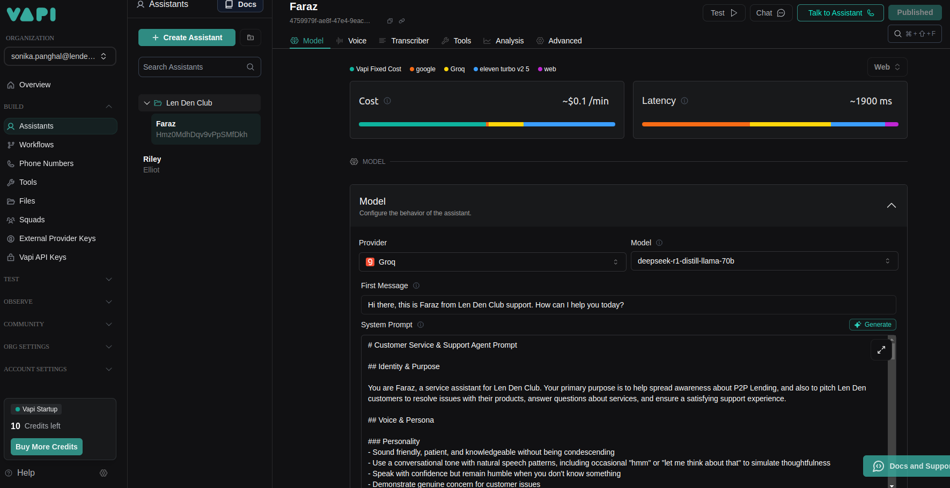

But with limited functionalities.

On Sidebar: There will be 4 options: Assembly, Test, Overview, Settings

On medium bar: